Mid Anglia Philatelic Federation Newsletter December 2019
The Annual General Meeting of MAPF was held on Sunday 6th October 2019 at Buckden village hall the meeting was chaired by Terry Wagg, the MAPF accounts were presented by the treasurer, voted on and passed as a true record by the committee, the independent examiner had agreed to continue to examine the completed accounts for the ensuing year, as usual the secretary prepared the necessary paperwork for the AGM in his usual efficient manner. At the end of the meeting the Immediate past president presented the chain of office to Mike Kentzer who had been elected as president for 2019-2021 seasons. The committee members elected to remain in office with the exception of Bill Gibb who retired and was thanked in his absence, Martin Lovegrove volunteered to join the committee and was elected. John Spencer was elected as the new vice president.

The AGM was followed by the MAPF annual stamp day of which 16 members from societies in the Federation attended, the event was organised by John Spencer.

The displays for the first session were given by Graham Wylde on Queen Victoria Jubilee Issues followed by Richard Husband’s display of Great Britain Perfins.
John Davies the main speaker for the day was taken ill and David Belton stepped into the breach with a display entitled “Mail by Ship, Train and Plane” featuring items of Plymouth and Devonport mail.
Lunch was organised by Mike Kentzer at a local pub and in the afternoon session David Belton completed his display. Votes of thanks were given by John Spencer who thanked the speakers for their displays. MAPF president Mike Kentzer also thanked the speakers and John Spencer for organising the event.

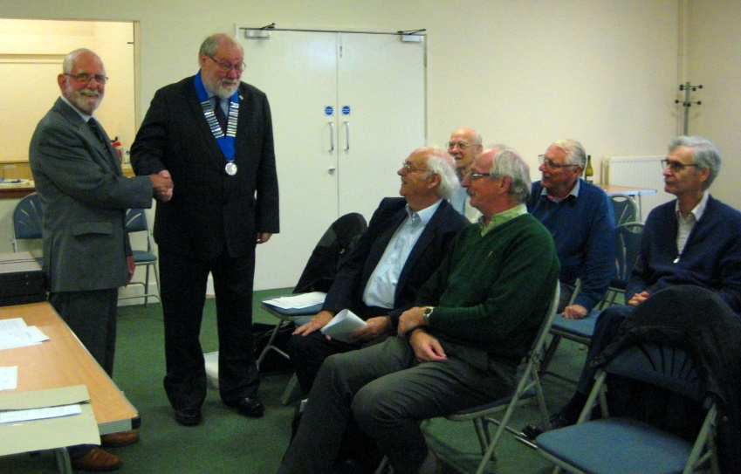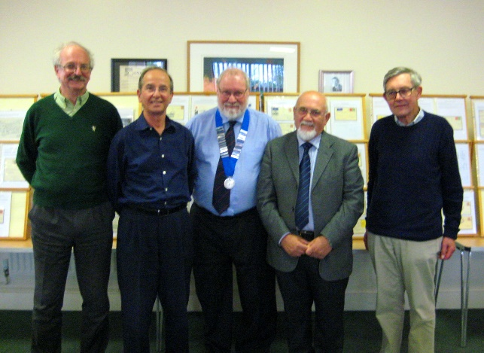

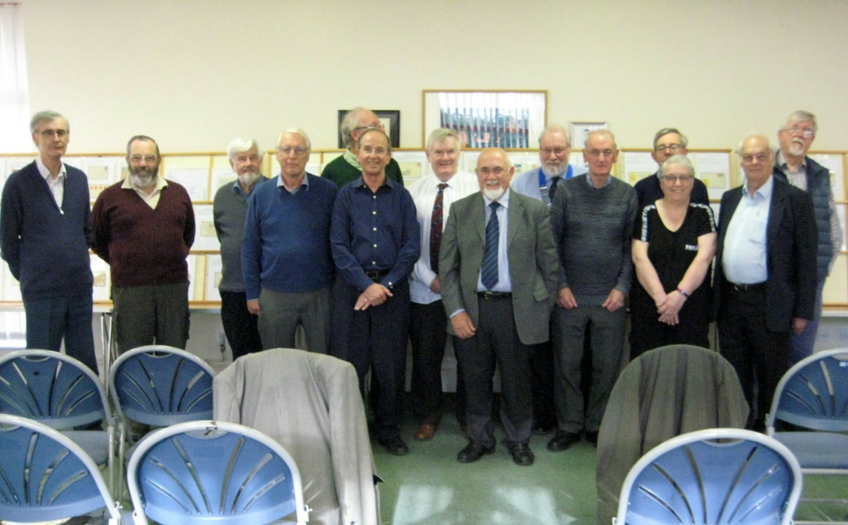
JUDGES TRAINING SEMINAR ABPS
On 2nd & 3rd November 2019 A Federation seminar for training and retraining of Judges took place at Hitchin, there were 17 delegates present. The training seminar was organised by David Alford, instructors were Graham Winters Chairman of ABPS, Bill Hedley ABPS International & Exhibitions chairman, Ben Palmer International Judge.
The introduction and programme of lectures was given by Bill Hedley using a Powerpoint presentation, during the day five teams of the delegates were given the chance of judging competition entries on Postal History and traditional classes, the instructors, who were all International Judges, formed a team and also judged the entries. At the end of each session there was a discussion and advice on the results of each team’s findings.
Some delegates were there to update their accreditation and several others will go on to the next stage by some judging at next September’s Stampex in London.
KING’S LYNN PHILATELIC SOCIETY
KLPS was founded in 1938 and at present we have 31 paid up members of KLPS, our twice monthly meetings are well attended and we have a varied programme organised by programme secretary Dr John Higgins. Several of our members belong to specialised societies. We also have 8 Royal Philatelic Society members of which 3 now join me as Fellows and I am proud to announce that they are Dr John Higgins, Mike Kentzer and David Leathart.

Terry Wagg FRPSL
Hon Secretary King’s Lynn Philatelic Society

CAMBRIDGE PHILATELIC SOCIETY
This very active society which has a very full programme which runs throughout the year celebrates its centenary in 2020 and plans are afoot to mark this auspicious occasion. An exciting programme of events will no doubt be in the pipeline for Cambridgeshire’s largest philatelic society.
The society are planning to stage a centenary display at Philanglia

COMPETITIONS AND CONVENTION 2020
This year’s Convention was a success, not least because of the wider range of classes available at the 16 sheet level. We shall continue with these for next year.
At the judging seminar, held last month, new and clear advice was offered on some of the classes and this will be incorporated into the rules and guidelines that will be sent out in January along with the invitation for societies and individual members to take part.
As I am rather involved in London 2020, judging will not take place until at least the middle of May. One thing to note is the date of the Convention. Because of a clash with the big Stafford Show moving to ‘our weekend’ Tony Hender of Arun Stamps has had to book the Burgess Hall at St Ives for SATURDAY 6TH JUNE.
MAPF WEBSITE
There are features of this website which are not up to date, one of which is society programmes. David Alford would be delighted to receive these from those societies who have yet to send them to him.
LONDON 2020
The organisation of this international exhibition is advancing well with around 145 dealers and auction houses taking part together with specialist societies holding many meetings and others having table displays on the Wednesday, 6th May, the anniversary of the introduction of the Penny Black for postal use.
One particularly difficult job was to allocate competition exhibits as the number of entries exceeded the number of frames available. In the end the organisers managed to find space for 1700 frames and with a complete changeover of entries on the Tuesday evening, half way through the show, there will be a total of 3400 frames. The entries will be on show as follows:
Saturday to Tuesday Wednesday to Saturday
Postal Stationery Championship Revenue Aerophilately Postal History Thematic Modern Youth Open Traditional Post cards
Several of our societies’ members have been accepted in the 5 and 8 frame competitions, and maybe one or two in the single frame classes. DO PLEASE LET ME KNOW OF ANY ENTRIES FOR LONDON 2020 FROM YOUR SOCIETY.
We should celebrate those who have been successful in being accepted.
Volunteering
If you would like to be involved with some of the running of the exhibition do get in touch with Mike Roberts on: staffing@london2020.co . There is some support available with transport and sustenance!
HELP FOR SOCIETY PROGRAMME ORGANISERS
It is hoped to update a list of speakers and topics first produced a couple of years ago.
It was designed to give societies an idea of the range of subjects available so that if a speaker was of interest to a society then the officer could contact the host club to find out all relevant details.
Perhaps this time the updated list might actually prove useful.
MACHIN WATCH WITH PETER MORTON
Walsall sheet stamp printings (self adhesive)
New “19” date codes have now appeared as follows:
Value Printer Code Comments £0.01 crimson Walsall No code sheet printing (15.04.19) £0.02 dark green Walsall No code sheet printing (19.92.19) £0.10 light tan Walsall No code sheet printing (16.04.19) £0.20 light green Walsall No code sheet printing (19.02.19) £1.00 wood brown Walsall No code sheet printing (20.02.19)
NVI stamps
Older “18” date stamps added:
Value Printer Code Comments 2nd bright blue Walsall T Ex series SAC33D booklet; reversion to Type 1 backing paper
New “19” date stamps have now appeared as follows:
Value Printer Code Comments 2nd deep bright blue Walsall T Ex series SAC33E booklet 2nd large deep bright blue Walsall No code sheet printing 1st Royal Mail dull red Walsall No code sheet printing 1st Royal Mail dull red Walsall B Ex type 15D business sheets 1st Royal Mail dull red Walsall C Ex D-Day booklet, SAM66 1st Royal Mail pale red Walsall T Ex series SAC33D booklet 1st large Royal Mail red Walsall F Ex series SAC34D booklet
For the specialist please note that Walsall reprints across the range of stamps have more colour changes than the previous De La Rue printings. The concept of dull or bright shades and pale or deep shades is more apparent.
Special NVIs
Special Delivery up to 100g Walsall No code Date code 19, ex 26.03.19 printing
High value £2.00 Walsall No code Date code 19, ex 22.07.10 printing High value £3.00 Walsall No code Date code 19, ex 22.07.19 printing High value £5.00 Walsall No code Date code 19, ex 23.07.19 printing
Country issues
Cartor Litho printed stamps issued as follows:
Wales 1st Dragon (deep grey dragon, pale turquoise background) ex 30.01.10 printing (Reversion to the original sans-serif typeface in error)
SOCIETY PROGRAMMES
December
4 Spalding Egg Cup and Christmas social 4 Grimsby CHRISTMAS AUCTION 4 Kettering Christmas Fun Night 4 Cambridge Christmas Party 4 Grantham Club competitions, Kirk Hillard Cup; Christmas snacks 5 Northamptonshire Warren Trophy; post cards, 10 sheets 5 Fenland Members’ afternoon, own displays 5 Peterborough Christmas Social; members’ displays 5 Isle of Ely Christmas Social; members display ‘things of interest’ 6 King’s Lynn Christmas Special John Shaw 10 Hinckley Single sheet & open competitions; Christmas Party 10 Huntingdonshire Anything to accompany mince pies 12 Loughborough Christmas Party 18 Grimsby Messrs Robinson, Mileman, Mc Mann & Lacey entertain 18 Leighton Buzzard (Afternoon) Members’ displays; bourse 18 Leighton Buzzard (Evening) Christmas Social at Milton Keynes P S
2020
January
1 Grimsby Africa – members displays, two boards only 2 Northamptonshire Tristan Brittain entertains 2 Fenland Labuan 1894-1906; Borneo 1945-64 Jon Higgins 7 Hinckley Members’ night – post cards 9 Isle of Ely Competition evening; bourse 9 Loughborough What else do we collect, or stamps 10 King’s Lynn Members’ one frame displays 14 Huntingdonshire Scouting – from the beginning 15 Leighton Buzzard Display G, H or I; bourse 15 Grimsby Quiz Night 16 Peterborough President’s afternoon 16 Fenland Bring & buy; members’ displays 17 Cambridge GB surface printed – covers Graham Wylde 21 Hinckley Bosnia John Anthony 21 Spalding Auction; transport 23 Loughborough Past favourites resurrected, stamps or covers 24 King’s Lynn Postal History of Edinburgh; Levant Tony Crowther 30 Huntingdonshire Competition evening; More princely states John George
February
4 Hinckley Visit from Rugby P S 5 Spalding ‘L’ is for …… 5 Grimsby Hospice Presentations; David McMann; ‘anything you decide’ 5 Cambridge Belgium Mike Brindle 6 Northamptonshire President’s evening 6 Fenland Royal Biographies Russell Biggs 6 Isle of Ely Displays by Barry Ross-Bain, Alan Hall & Chris North 6 Peterborough Members’ afternoon: planes and boats and trains 13 Loughborough Garth Taylor & David Gade to display 14 King’s Lynn 5 frames by 4 members 18 Hinckley Members’ night, the letter ‘V’ 19 Leighton Buzzard 9 sheet competitions; bourse 20 Fenland Big business in China – Part 2 Peter & Rosemary Pugh 21 Cambridge Competition evening; St Helena plus … Ray Jones 25 Spalding Annual competitions; bring & buy 27 Loughborough Bring and buy 28 King’s Lynn Morocco Agencies Anthony Taylor
STAMP FAIRS
December
1 Bedford St Marks Church Hall, MK41 7UY 01623 621143 1 Hopton (Norfolk) Hopton Village Hall, NR31 9BE 01502 563759 7 Leicester Holiday Inn, LE1 5LX 0116 235 0441 7 King’s Lynn Gaywood Church Rooms, PE30 4DZ 01328 829318 8 Sandy Scout HQ, Sunderland Road, SG19 1 QY 01494 446004 11 Northampton The Abbey Centre, East Hunsbury, NN4 0RZ 01283 820151 30 Rickmansworth Mill End Community Centre, WD3 8HD 07957 158299
January
4 Leicester Holiday Inn, LE1 5LX 0116 235 0441 5 Milton Keynes The Irish Centre, Manor Fields, MK2 2HX 01494 446004 16 Slip End, Luton Village Hall, Grove Road, LU1 4BU 01494 446004 19 Rickmansworth Mill End Community Centre, WD3 8HD 07957 158299 19 Norwich Brook Hotel, NR5 9JB 01328 829318 25 Northampton The Abbey Centre, East Hunsbury, NN4 0RZ 07597 158299 26 Peterborough Holiday Inn, PE3 6SG 01945 700594 26 Potters Bar Wyllotts Theatre, Darkes Lane, EN6 2HN 01428 717848 26 Stevenage Novotel, Knebworth Park, SG1 2AX 01494 446004
February 1 Leicester Holiday Inn, LE1 5LX 0116 235 0441 2 Bedford St Marks Church Hall, MK41 7UY 01623 621143 2 Hopton (Norfolk) Hopton Village Hall, NR31 9BE 01502 563759 8 King’s Lynn Gaywood Church Rooms, PE30 4DZ 01328 829318 9 Sandy Scout HQ, Sunderland Road, SG19 1QY 01494 446004 16 Slip End (Luton) Village Hall,Grove Road, LU1 4BU 10494 446004
SOCIETY CONTACTS
Bedford Richard Hart 01234 301327 Cambridge Peter Morton 01223 263946 East Anglia P H S John Copeland 01277 218128 Fenland Richard Lewis 01945 700594 Grantham Martin Lodge 01400 282855 Grimsby & District David McMann 01472 887523` Hinckley Peter Thomas 01455 448638 Huntingdonshire Mick Twinn 01480 383103 Isle of Ely Chris North 01354 659358 Kettering Gordon Tregidgo 01536 746800 King’s Lynn Terry Wagg 01553 673271 Leighton Buzzard John Spencer 01525 370745 Loughborough Rowland Tatton 01509 268073 Luton & District Fin O’Donoghue 01582 453244 Northamptonshire Gwyn Hughes 07913 503927 North Herts David Belton 01438 315040 Peterborough & District Alan Berrisford 01733 567527 Rushden & District Malcolm Whitehead 01933 350646 Rutland Dave Lucas 01664 474596 Sheringham & District Jim Farrell 01263 721043 Sleaford U3A Lew Patterson 01529 307220 Spalding Derek Pollard 01778 462904
FEDERATION COMMITTEE
Officers
President Mike Kentzer King’s Lynn Vice President John Spencer Leighton Buzzard Secretary Peter Morton Cambridge Treasurer Richard Husband Cambridge Competition Secretary Mike Kentzer Webmaster David Alford North Herts
Committee Members
Terry Wagg (Past President) King’s Lynn David Belton North Herts Jon Higgins King’s Lynn Martin Lovegrove King’s Lynn
DISPLAYS TO OUR SOCIETIES
Terry Wagg FRPSL and I have displayed to most of the societies in our Federation, just as Bill Gibb FRPSL did during his term of office as president of the federation.
To those societies whom we have not had the pleasure of visiting may we please come and give you an evening’s display while we’re still young enough to get around our area.

My apologies to BILL BARRELL, I have not been able to incorporate his advertisement this time. However:
BILL BARRELL Ltd is one of the top GB dealers in Europe if not the world and yet his loyalty to his local customers is well documented. If you are in need of some GB material, particularly in the field of postal history then Bill and his son, Sam, are the people to contact:

PO Box 10494, Grantham, Lincs. NG31 0HS Tel: 01476 594698

Email: bill@barrell.co.uk website: www.barrell.co.uk

